Annual Meeting and Hands-on Workshop
of the MC RTN project CELLION
Cracow, 26-30 January 2005
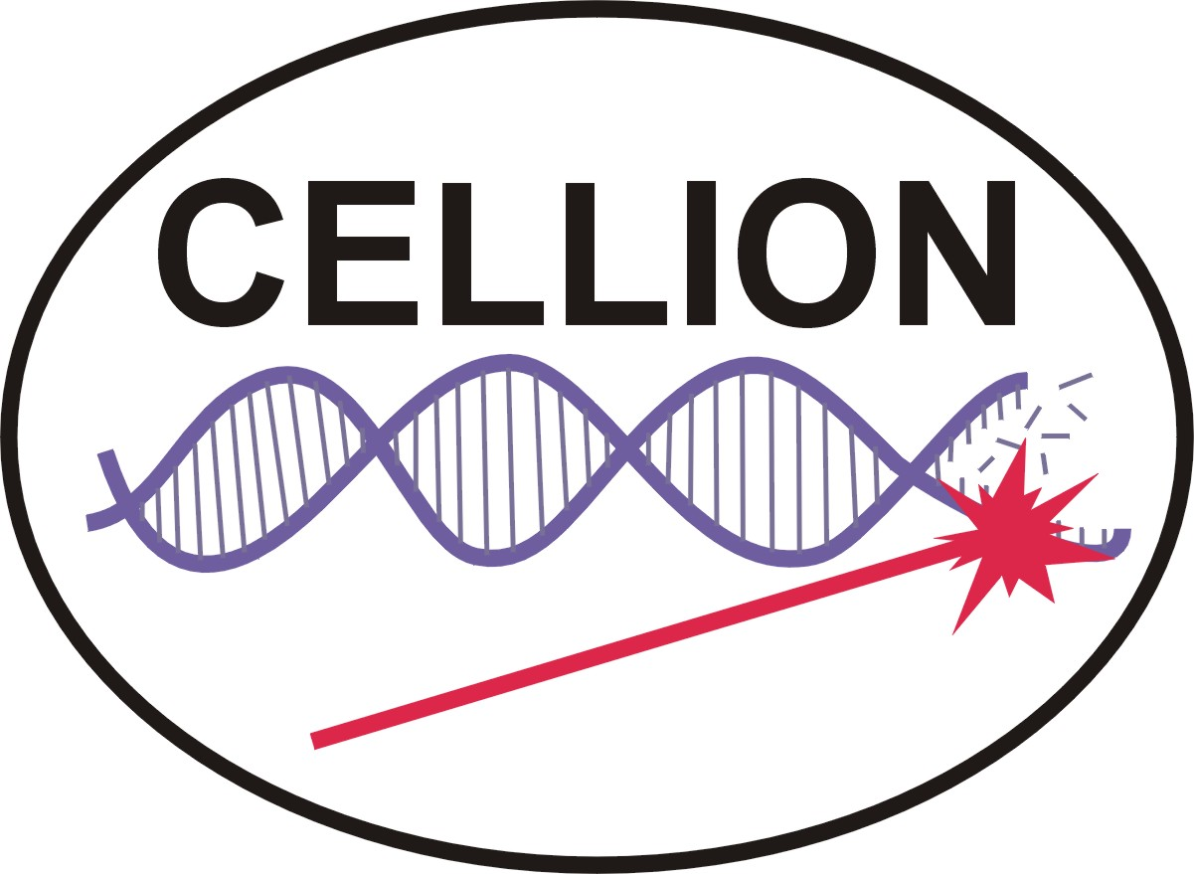

Wednesday, 26 Jan. 2005
Arrival and registration in Hotel “Witek”
(Hotel address: Kraków, Modlniczka 124a,
phone: (+48-12) 66 23 500
mobile: (+48) 691 550 550 )
Thursday, 27 Jan. 2005
9:00 – 9:15 Welcome and introduction
9:15 – 10:30 task presentations (conference room – level -1)
by bursars of the project CELLION
(IFJ PAN, GSI, CM UJ, Bordeaux)
10:30 – 11:00 coffee break
11:00 – 12:30 continuation of task presentations
(Leipzig, Lund, Surrey, Uppsala)
12:30 – 14:00 lunch
14:00 – 15:00 M. Lekka (invited) – Application of AFM in biology
15:00 – 15:30 micro-bus transportation to the IFJ PAN
15:30 – 18:30 hands-on workshop on atomic force microscopy
18:45 return to the hotel or excursion to the city centre
Friday, 28 Jan. 2005
9:00 micro-bus transportation to the Collegium Medicum of Jagiellonian University
9:30 – 10:30 M. Zazula (invited) – To win hereditary cancer – mission impossible?
10:30 – 13:00 hands-on workshop on electron microscopy and molecular genetics
13:00 – 14:30 lunch
afternoon – individual excursions to the city centre
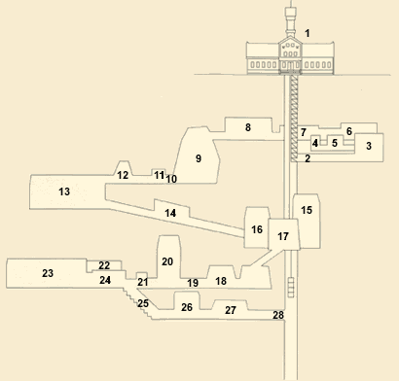
Saturday, 29 Jan. 2005
8:45 excursion to the salt mine in Wieliczka
(10 km from Cracow). The mine was exploited
since medieval times until today. A map of
touristic route is shown in the right. Wieliczka
salt mine is in the UNESCO list of the most
important cultural monuments in the world.
15:00 – lunch
16:00 – 17:30 annual meeting of CELLLION
17:30 – 18:00 coffee break
18:00 – 18:30 annual meeting – continuation
19:30 departure for the conference dinner
Sunday, 30 Jan. 2005
departure
Thank you for joining us!
Attention, please! This is for participants taking part in the NANODERM meeting: the meeting starts on Sunday afternoon and will take place in the same hotel.

